“Made with Real Fruit”: Natural and Historical Identity Construction in Yogurt
Orientation:
Advertising and food packaging are intrinsically linked. Everything from appeasing images on a box to nutritional information can be used to sell products off the shelf. Even the most innocuous items contain swaths of information to entice and excite the reader into supporting their brand, but there are different methods to appeal depending on the targeted clientele. Food descriptions, specifically, are one method with which an advertiser can appeal to different social groups and their values. In this paper, I expand on previous linguistic analyses of food packaging by analyzing the language of two distinct, differently priced yogurts and inferring the implied values of the socioeconomic class of its consumers revealed as a result.
My work for this paper explores some of the principles developed by Freedman and Jurafsky in their 2011 paper “Authenticity in America”, which examines linguistic markers on potato chip packages and relates them to specific class ideals. One key feature explored in this paper is the idea of authenticity. The writers define authenticity as features in food or dining, like tradition, cooking process, or ingredient sourcing, that contribute to the item’s “realness”. The authors use four categories to describe authentic words: Naturalness, Ingredients/process, Historicity, and Locality (Freedman and Jurafsky, 2011).
In this work, I also build on previous research related to language in restaurants. In a subsequent paper in 2016, Jurafsky relates his previous analysis of authenticity to restaurant menus. Though the language exists in separate formats, many of Jurafsky’s findings in this paper relate strongly to “Authenticity in America” and can be incorporated into this analysis. I also examine Lakoff (2006) for elaboration on some of the trends I find.
For this study, I examine the individual packages of two different brands of yogurt: Yoplait and Icelandic Provisions, retailing at 50 cents and $1.99 per container, respectively. In this analysis, I will demonstrate how language is used to promote differing authenticities for each brand and thus construct identities aimed to appeal to each yogurt’s ideal consumer.
Analysis:
Differences in authenticity were the most obvious distinction between the two yogurt brands I researched. Authenticity is unique in that it’s talk can be constructed in a variety of ways, meaning any brand can highlight the authentic features of their product which will appeal the most to their consumers. Building on the previous literature I examined, there are two main trends for authenticity: cheaper brands or restaurants tend to emphasize their traditional or historical authenticity while more expensive brands highlight their naturalness and the quality of their ingredients (Freedman and Jurafsky, 2011; Jurafsky, 2016). Specifically, Freedman and Jurafsky (2011) found that naturalness was mentioned 2.5 more times on expensive chips while historicity and locality were more commonly expressed on inexpensive chips. Jurafsky (2016) also found a strong correlation between restaurant price and the emphasis on natural authenticity in their menu. Expanding on these findings, I sought to investigate how Yoplait and Icelandic provisions emphasize their product’s authenticity through their product labels.
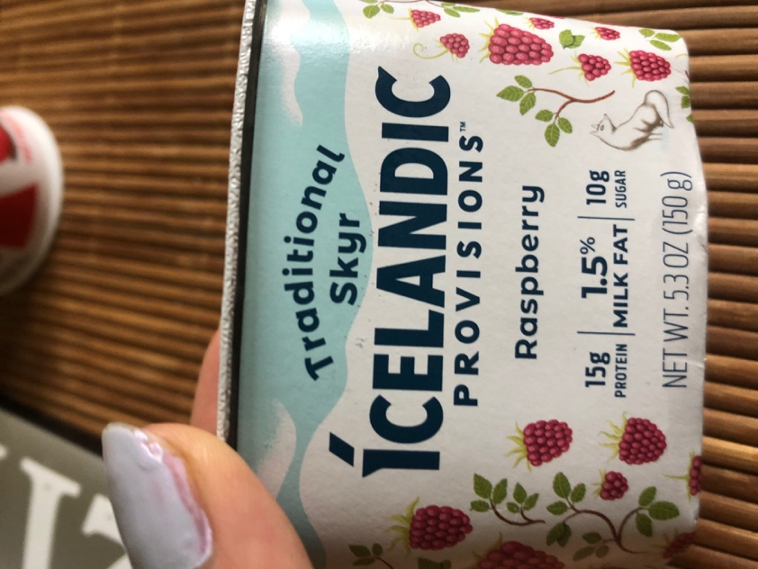
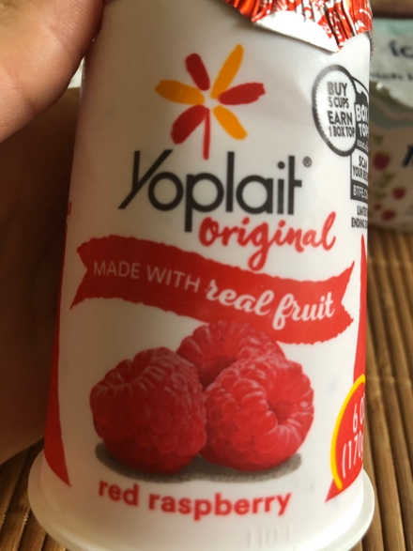
Converse to the previous literature, I found natural authenticity to be the main identifier Yoplait, the cheaper yogurt I examined. Of the two packages I analyzed, natural or ingredients-based indicators like “No artificial flavors”, “real”, or “active cultures” appeared a total of ten times, eight of which came from the Yoplait packaging. The front of each package, which elucidates some of these differences, is pictured below:
The difference between these two brands with respect to their naturalness is striking with respect to how each portray their ingredients on the front of their labels. Though seemingly insignificant, the two brands refer to the flavor of their yogurt differently. Yoplait advertises a “red raspberry” while Icelandic Provisions uses the flavor of “raspberry”. While both speak to their yogurt’s ingredients with these phrases, the Yoplait packaging also emphasizes the product’s naturalness with the adjective “red”, commenting on the freshness and the quality of the particular raspberries used for their yogurt.
The fronts of each brand’s packaging demonstrate another difference in naturalness. While Icelandic provisions provides no other comment on the quality of their raspberries, Yoplait emphasizes that their yogurt is “made with real fruit”. This phrase affirms both the quality of Yoplait’s yogurt as well as the construction of Yoplait’s natural authenticity. This statement, however, along with “red raspberries” explored earlier, may violate Grice’s maxim of quantity. In his analysis of restaurant menus, Jurafsky (2016) noted that the use of adjectives related to quality could be interpreted as needing to fulfill the communicative goal of convincing the reader of its truth, per Grice’s maxims (Grice, 1989 as cited by Jurafsky, 2016). By this understanding, the reputation of Icelandic Provisions might be served by not commenting on the quality of their ingredients, as their yogurt is already understood to be worth its high price.
While the quality and naturalness of ingredients are marked in the Yoplait packaging, Icelandic Provisions’ packaging emphasizes its historical authenticity. Contrary again to Freedman and Jurafsky’s (2011) findings, who conclude that historicity and locality are more likely to be emphasized with cheaper potato brands, the majority of historical and local markers (5/6) are found on the Icelandic Provisions packaging. The only direct comparison of authenticity between the two brands is seen in the front images. The Yoplait brand uses “original” to refer to its yogurt while Icelandic Provisions uses “traditional”. Though both terms refer to each’s yogurt’s historical authenticity, “traditional” does this more explicitly, carrying connotations for the brand’s Icelandic ties. “Original”, on the other hand, could merely refer to one particular Yoplait variety.
More explicit examples of historical authenticity come from Icelandic Provision’s product description, pictured below.
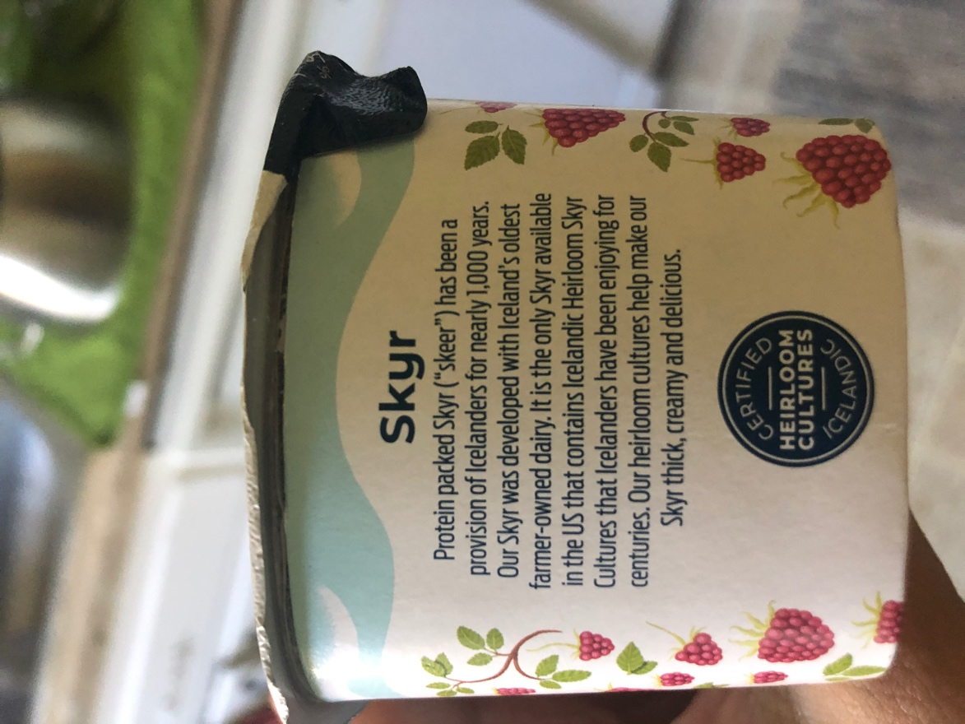
In this image, the construction of historical and local authenticity is emphasized, with nearly the entire paragraph describing the product’s past. Icelandic Provisions informs readers that their Skyr “has been a provision of Icelander for nearly 1000 years” and that their yogurt is “developed with Iceland’s oldest farmer-owned dairy”. Not only do each of these phrases verify the historical authenticity of this product, but the repetition of Iceland and the specific term for this type of yogurt and how to pronounce it “Skyr (‘skeer’) invites its consumers to join the culture themselves and attribute this worldliness to their own identity (Lakoff, 2006).
Reflection:
In this analysis, I demonstrated how the construction of authenticity may differ from what is expected based on the particular products explored. From my research, I found the less expensive yogurt brand Yoplait is more focused on constructing a natural authenticity and may suggest its ideal customers are more concerned with quality, though this may come from a need to prove Yoplait’s yogurt is genuine. Icelandic Provisions, the more expensive yogurt brand I examined, however, focused on highlighting its historical authenticity, suggesting its customers already understand the yogurt’s quality and are more interested in the brand’s worldliness and cultural significance. This difference in authenticity construction may reflect the intricate dynamics of advertising as more expensive brands try to demonstrate ethical, local practices and no longer need to highlight the quality of their ingredients. Conversely, this could simply reflect trends related to a specific type of product, rather than broad generalizations about language usage on packaging, which should be examined in future analyses.

Appendix:
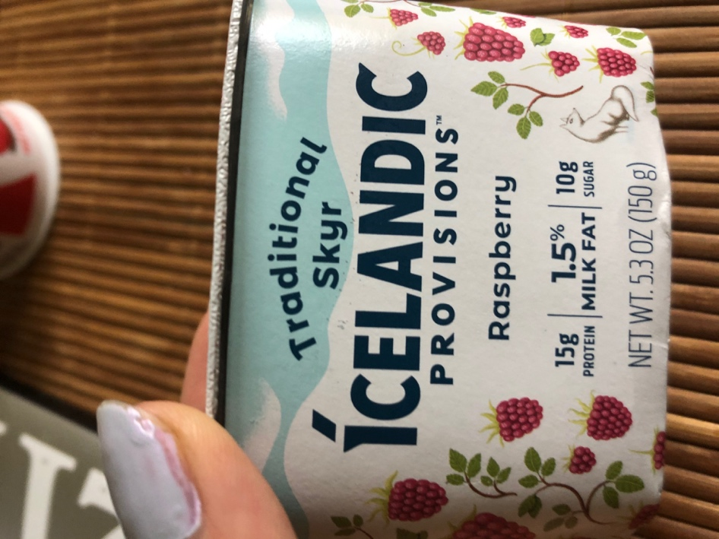
Example 2: Side of Icelandic Provisions Package
Example 1: Front of Icelandic Provisions Package.

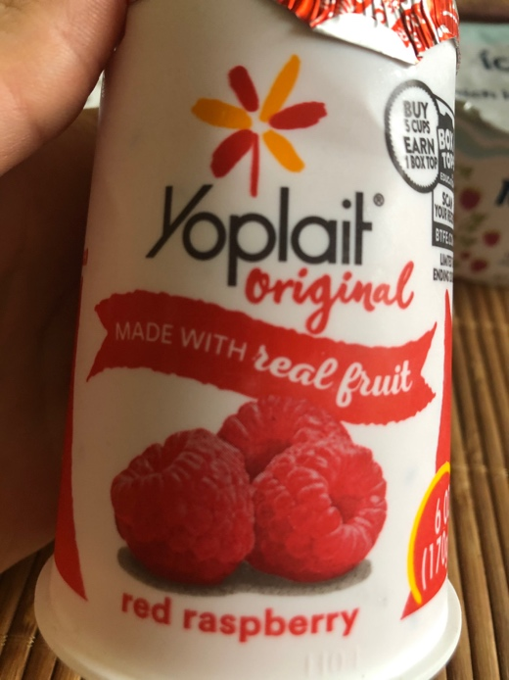
Example 3: Front of Yoplait Package.

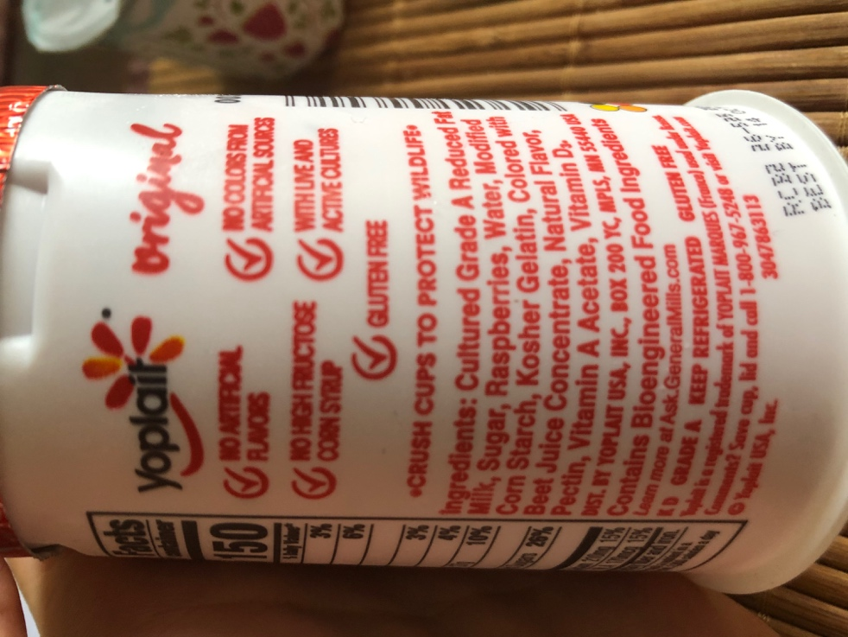
Example 4: Back of Yoplait package.

References:
Freedman, J., & Jurafsky, D. (2011). Authenticity in America: Class distinctions in potato chip advertising. Gastronomica: The journal of food and culture, 11(4), 46-54.
Grice, H. P. (1989). Studies in the Way of Words. Harvard University Press.
Jurafsky, D., Chahuneau, V., Routledge, B., & Smith, N. (2018). Linguistic markers of status in food culture: Bourdieu’s distinction in a menu corpus.
Lakoff, R. (2006). Identity à la carte: You are what you eat. Studies in Interactional Sociolinguistics, 23, 142.

